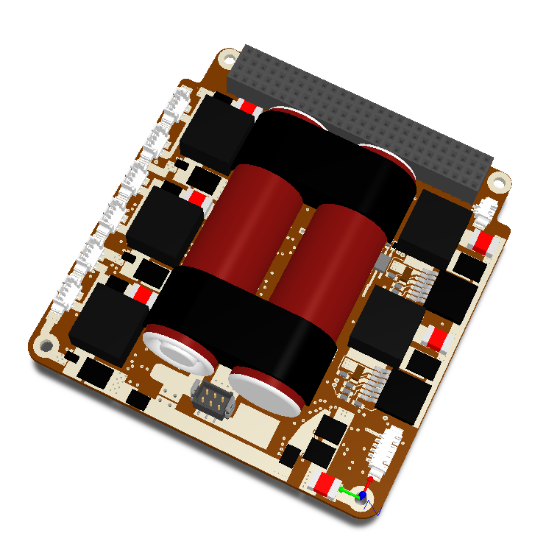

**Technical Specification of Gomspace PCB 2104**

Project name: nanopower-p31u-9

PCB ID: 2104

NECAS ID: 700-1680-050

Specification version: 1

Replaces specification: -

Written by: Karl Kaas Date: 18.03.14

PCB designer Name: Karl Kass Design release Date: 18.03.14

Approved by: Approved Date:

1. Enclosure

Enclosed with this specification is a .zip file with extender gerber and netlist data files

and a .pdf file with artwork prints for identification purposes.

If inconsistency is observed between this specification and the attached data, the information

stated herein is valid and Gomspace needs to be notified.

For parameters not specified herein the defined standard below is valid.

2. Base specification:

|  |  |
| --- | --- |
| IPC-A600 cl.2 |  |
| IPC-6012 cl.2 |  |
| IPC-6012 cl.3 |  |
| IPC-6012 cl.3/A |  |
| IPC-6018 cl.2 |  |
| ESA ECSS-Q-ST-70-11-C | x |

3. Construction:

|  |  |
| --- | --- |
| Single/double sided |  |
| Multilayer | X |
| Rigid/flex |  |
| HDI multilayer 1-N-1, µvias |  |
| Other: |  |

4. Material type:

|  |  |
| --- | --- |
| Glass/polyimide (GI) IPC-4101/40 | x |
| Glass/Epoxy (GF) IPC-4101/126 |  |
| Other: |  |

5. Design Parameter Values

|  |  |
| --- | --- |
| Board size: 93,17mm x 89,28mm | Layer count: 6 |
| Board thickness measured over bare substrate: 1.6mm | |
| Minimum Track Width: 200um | Minimum Hole Size: 300um |
| Minimum Spacing 150um | Minimum via pad size: um |

6. Solder finish:

|  |  |
| --- | --- |
| Hot oil reflow tin/lead | X |
| HAL leaded |  |
| HAL lead-free |  |
| ENIG |  |
| Other: |  |

7. Other processes:

|  |  |  |  |
| --- | --- | --- | --- |
| Soldermask liquid |  | Soldermask laminated |  |
| Notation upper side |  | Notation lower side |  |
| Countersink | x | Goldplating |  |
| Copper fill requirement |  | Other: |  |

8. Test to perform:

|  |  |
| --- | --- |
| Electrical test: | X |
| Impedance test: |  |
| IST: |  |

9. Delivery panel information

|  |  |
| --- | --- |
| Delivery in panels: | **TO BE COMPLETED BY NECAS** |
| Panel size x – y: | **TO BE COMPLETED BY NECAS** |
| Number of PCB’s in X: | **TO BE COMPLETED BY NECAS** |
| Number of PCB’s in Y | **TO BE COMPLETED BY NECAS** |
| Scrapped boards in panel accepted: | Yes |
| Panel construction contacts: | Necas |

10. Packaging

Packaging to be separate one by one in antistatic bag, and then 10 into a bigger bag.

Mil-P-116G method 1A-8

**Appendix 1. Build-up**

Lag: 6

Materiale: Polyamid

Overflade: tin-bly

Kobber: 70u/70u

Sluttykkelse: 1.6mm

Lag rækkefølge:

Top: GTL

I1: GP1

I2: G1

I3: G2

I4: GP2

Bot: GBL

Outline: GM10

Drill: NanoPower P31u-9-drill.TXT

**Specielle hensyn:**

1) To platerede monteringshuller undersænkes fra undersiden. Jeg har vedhæftet et screenshot hvor de to huller er markeret med en grøn cirkel. Undersænkningen er af samme type som på ordre nanopower-p31u-8-1444.

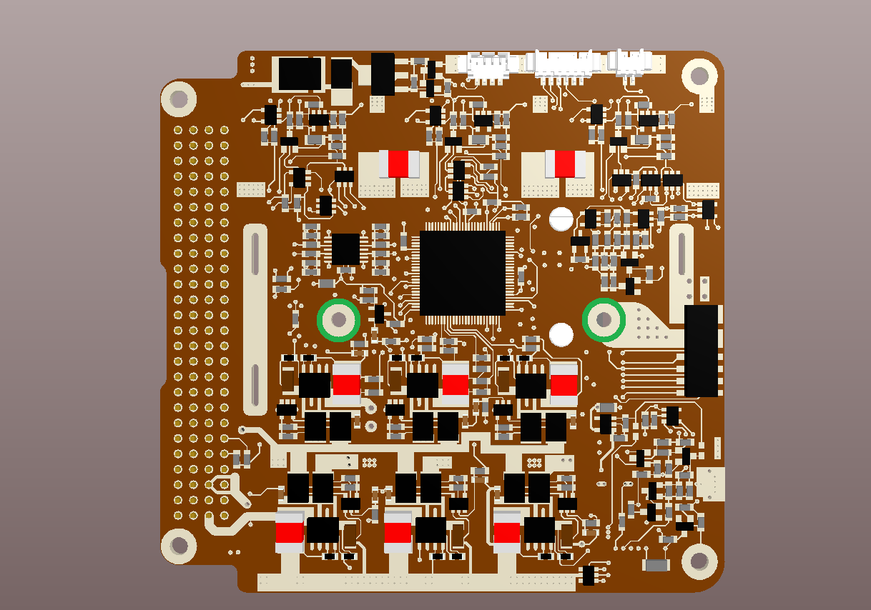

Impedance requirements, none.

**Appendix 2.**

Hole table.

General tolerance on holes +/- 0.05mm for non plated holes, and +/-0.1mm for plated holes.